Hotel Room Booking System
Case Study on Database Management System (DBMS)
A CASE STUDY REPORT
Submitted by:
Keshav Saini
UID: 25BCD10101
Section: 25BCD2
Submitted to:
Name: Mrs. Harkamal Kaur
Designation: Assistant Professor
in partial fulfillment for the award of the degree of
BACHELOR OF COMPUTER APPLICATIONS (HONOURS)
IN
DATA SCIENCE
Chandigarh University
Date of Submission: ____ / ____ / 2026
ABSTRACT
This case study describes the analysis, design and implementation of a Hotel Room Booking System using a relational database. A hotel has to keep track of guests, rooms, room categories, reservations and payments. When this is done manually, rooms get booked twice, bills are miscalculated and reports take a lot of time. A database solves these problems by keeping all data in one place and enforcing rules on it.
The study covers requirement analysis, the ER model, the relational schema, normalisation up to Third Normal Form, and an SQL implementation with five tables, constraints, a view, a trigger, an index and transactions. All queries were executed on SQLite and their real output is shown. The tests prove that wrong data (duplicate phone numbers, invalid dates, unknown guests) is rejected, that overlapping bookings are blocked automatically, and that a rolled-back transaction leaves no trace.
TABLE OF CONTENTS
Abstract 2
Chapter 1 – Introduction 2
Chapter 2 – Requirement Analysis 3
Chapter 3 – Database Design 4
Chapter 4 – Implementation and Results 5
Chapter 5 – Testing and Validation 15
Chapter 6 – Conclusion and Future Work 15
References 15
CHAPTER 1. INTRODUCTION
1.1 Background
A hotel handles a continuous flow of information: who the guests are, which rooms exist, which room is free on which dates, how much a stay costs and how much has been paid. Paper registers and separate spreadsheets are slow and error-prone. A Database Management System (DBMS) stores this information in related tables, keeps it consistent and answers questions with a single query.
1.2 Problem Statement
To design a relational database for a hotel that (i) stores guests, rooms, room categories, bookings and payments without repeated data, (ii) finds the rooms that are free for any date range, (iii) never allows the same room to be booked twice for overlapping dates, (iv) calculates the bill and the pending balance of every booking, and (v) produces reports for the management.
1.3 Objectives
- To analyse the requirements and business rules of a hotel booking process.
- To draw the ER diagram and convert it into a relational schema.
- To normalise the data up to Third Normal Form (3NF).
- To implement the database in SQL with keys, constraints, a view, a trigger and an index.
- To demonstrate transactions (COMMIT and ROLLBACK) and test the integrity rules.
1.4 Scope and Tools
The case study covers the database layer only; a front-end is outside the scope. SQL was run on SQLite 3.45 using a small Python script (run_sql.py) that executes the SQL file step by step and prints each result.
CHAPTER 2. REQUIREMENT ANALYSIS
2.1 Users of the System
User | What the user needs to do
Receptionist | Register guests, search free rooms, create and cancel bookings, record check-in and check-out, take payments.
Manager | See revenue by room type, pending payments, payment methods used and the rooms that are never booked.
Guest | Gets a correct bill for the number of nights stayed and a record of the payments made.
2.2 Functional Requirements
- Store guest details: name, phone, e-mail and city.
- Store rooms with floor, category (type) and status: Available, Occupied or Maintenance.
- Store the price per night and capacity of each room category once.
- Create a booking for a guest and a room with check-in and check-out dates; a booking can be Booked, Checked-In, Checked-Out or Cancelled.
- Record one or more payments (Cash, Card or UPI) against a booking.
- Calculate nights, bill and balance of each booking, and give reports.
2.3 Business Rules
No. | Rule | How the database enforces it
R1 | Every guest has a unique phone number. | UNIQUE constraint on guest.phone
R2 | Price must be positive and a payment amount must be positive. | CHECK constraints
R3 | A room status can only be Available, Occupied or Maintenance. | CHECK constraint on room.status
R4 | The check-out date must be after the check-in date. | CHECK constraint on booking
R5 | A booking must belong to an existing guest and an existing room. | FOREIGN KEY constraints
R6 | A room cannot have two active bookings for overlapping dates. | Trigger trg_no_double_booking
R7 | Payment method must be Cash, Card or UPI. | CHECK constraint on payment.method
R8 | The bill is nights × price per night and is not stored. | View v_booking_bill
CHAPTER 3. DATABASE DESIGN
3.1 Entities and Relationships
Five entities were identified: Guest, RoomType, Room, Booking and Payment. One room type has many rooms; one guest and one room can each have many bookings; one booking can have many payments (for example an advance and a final payment). All relationships are one-to-many.
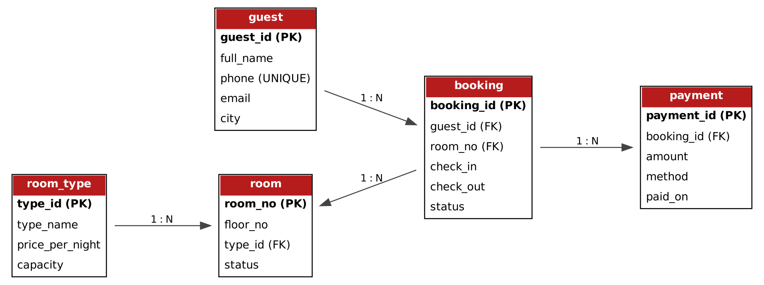
Fig. 3.1 – ER diagram (PK = primary key, FK = foreign key)
3.2 Data Dictionary
Table.Column | Type | Constraint | Meaning
guest.guest_id | INTEGER | PRIMARY KEY | Unique id of the guest
guest.full_name | TEXT | NOT NULL | Name of the guest
guest.phone | TEXT | NOT NULL, UNIQUE | Contact number
guest.email, city | TEXT | optional | E-mail and home city
room_type.type_id | INTEGER | PRIMARY KEY | Id of the room category
room_type.type_name | TEXT | NOT NULL, UNIQUE | Standard, Deluxe, Family, Suite
room_type.price_per_night | INTEGER | NOT NULL, CHECK > 0 | Rent for one night
room_type.capacity | INTEGER | NOT NULL | Number of guests allowed
room.room_no | INTEGER | PRIMARY KEY | Room number
room.floor_no | INTEGER | NOT NULL | Floor of the room
room.type_id | INTEGER | FOREIGN KEY → room_type | Category of the room
room.status | TEXT | CHECK (3 values), DEFAULT Available | Current status
booking.booking_id | INTEGER | PRIMARY KEY | Id of the booking
booking.guest_id | INTEGER | FOREIGN KEY → guest | Who booked
booking.room_no | INTEGER | FOREIGN KEY → room | Which room
booking.check_in, check_out | TEXT (date) | NOT NULL, check_out > check_in | Dates of stay
booking.status | TEXT | CHECK (4 values), DEFAULT Booked | State of the booking
payment.payment_id | INTEGER | PRIMARY KEY | Id of the payment
payment.booking_id | INTEGER | FOREIGN KEY → booking | Booking that was paid
payment.amount | INTEGER | NOT NULL, CHECK > 0 | Amount paid
payment.method, paid_on | TEXT | method CHECK (Cash, Card, UPI) | How and when it was paid
3.3 Normalisation
Suppose all information were kept in one table Hotel(booking_id, guest_name, guest_phone, guest_city, room_no, room_type, price_per_night, capacity, check_in, check_out, payment_1, payment_2, …). This causes update, insertion and deletion anomalies: the price of a Deluxe room would be repeated in every booking, and changing a guest’s phone number would need many updates. Normalisation removes this:
Form | Problem found | Solution
1NF | Repeating group payment_1, payment_2 … in one row. | Move payments to their own table, one row per payment.
2NF | guest_name, phone, city depend only on the guest, not on the whole booking; room details depend only on the room. | Separate tables guest and room.
3NF | room_no → type_id → price_per_night, capacity (a transitive dependency). | Move price and capacity to room_type.
The result is the five-table schema of Section 3.2, in which every non-key column depends on the key, the whole key and nothing but the key. The bill is not stored because it can be calculated from nights and price.
3.4 Relational Algebra of Important Queries
Query | Relational algebra
Rooms with their type | π room_no, floor_no, type_name, price (room ⋈ room.type_id = room_type.type_id room_type)
Available rooms for dates d1–d2 | π room_no (σ status ≠ ‘Maintenance’ (room)) − π room_no (σ status ∈ {Booked, Checked-In} ∧ check_in < d2 ∧ check_out > d1 (booking))
Bill of a booking | π booking_id, nights × price (booking ⋈ room ⋈ room_type)
Revenue per room type | type_name ℱ COUNT(booking_id), SUM(bill) (room_type ⋈ room ⋈ booking)
CHAPTER 4. IMPLEMENTATION AND RESULTS
Every statement of this chapter was executed in the order shown, one after the other on the same database, and the screenshots are the real output. The complete SQL is in the file sql/hotel_booking.sql.
4.1 Creating the Tables (DDL)
The CREATE TABLE statements define the five tables with their primary keys, foreign keys and CHECK constraints. The query below the code lists the tables created.
CREATE TABLE guest (
guest_id INTEGER PRIMARY KEY,
full_name TEXT NOT NULL,
phone TEXT NOT NULL UNIQUE,
email TEXT,
city TEXT
);
CREATE TABLE room_type (
type_id INTEGER PRIMARY KEY,
type_name TEXT NOT NULL UNIQUE,
price_per_night INTEGER NOT NULL CHECK (price_per_night > 0),
capacity INTEGER NOT NULL
);
CREATE TABLE room (
room_no INTEGER PRIMARY KEY,
floor_no INTEGER NOT NULL,
type_id INTEGER NOT NULL REFERENCES room_type(type_id),
status TEXT NOT NULL DEFAULT 'Available'
CHECK (status IN ('Available','Occupied','Maintenance'))
);
CREATE TABLE booking (
booking_id INTEGER PRIMARY KEY,
guest_id INTEGER NOT NULL REFERENCES guest(guest_id),
room_no INTEGER NOT NULL REFERENCES room(room_no),
check_in TEXT NOT NULL,
check_out TEXT NOT NULL,
status TEXT NOT NULL DEFAULT 'Booked'
CHECK (status IN ('Booked','Checked-In','Checked-Out','Cancelled')),
CHECK (check_out > check_in)
);
CREATE TABLE payment (
payment_id INTEGER PRIMARY KEY,
booking_id INTEGER NOT NULL REFERENCES booking(booking_id),
amount INTEGER NOT NULL CHECK (amount > 0),
method TEXT NOT NULL CHECK (method IN ('Cash','Card','UPI')),
paid_on TEXT NOT NULL
);

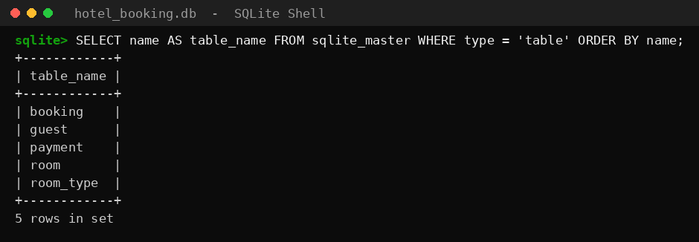
Output 1 – Tables created
4.2 Inserting Sample Data (DML)
Four room types, 10 rooms, 7 guests, 8 bookings and 6 payments are inserted. The query counts the rows of every table.
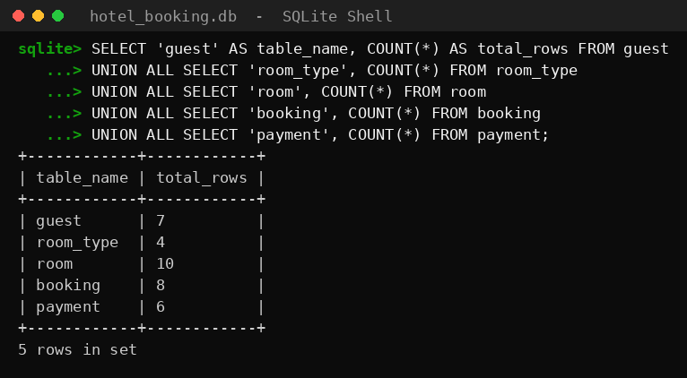
Output 2 – Row count of every table
4.3 Rooms with Their Type (INNER JOIN)
The room table is joined with room_type so that each room shows its category, price and capacity.
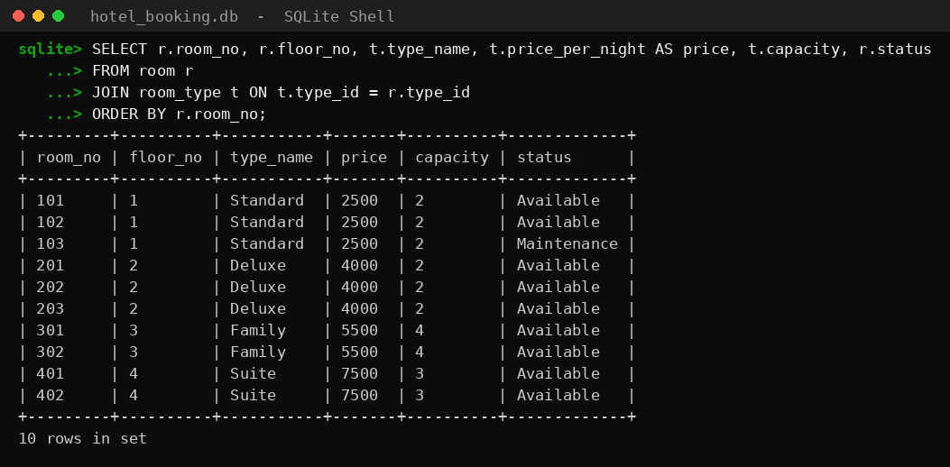
Output 3 – INNER JOIN
4.4 Searching Available Rooms (NOT EXISTS)
Rooms free from 25 to 28 October 2026: rooms under maintenance and rooms with an active overlapping booking are excluded.
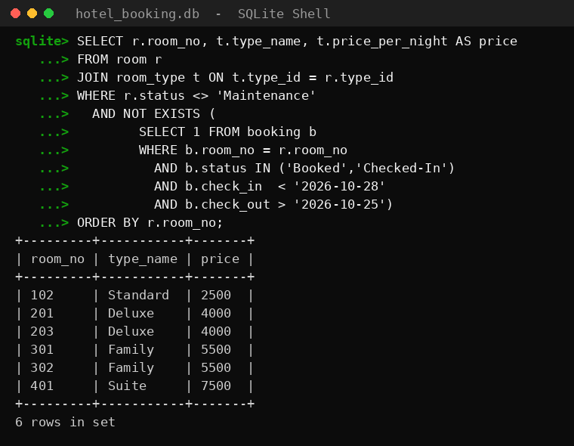
Output 4 – Available rooms
4.5 Trigger Against Double Booking
The first insert (room 202, 25–27 Oct) overlaps an existing booking of 24–26 Oct and is rejected by the trigger. The second insert (room 203) is accepted and becomes booking 9.
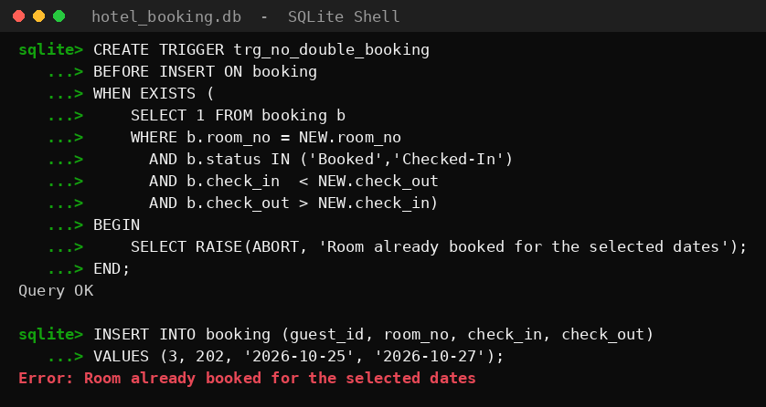
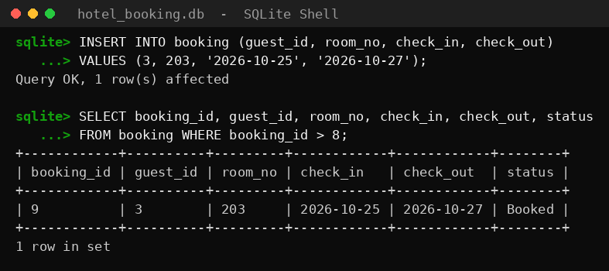
Output 5 – Trigger in action
4.6 View for Bill Calculation
The view v_booking_bill joins four tables and calculates nights, bill (nights × price) and amount paid for every booking.
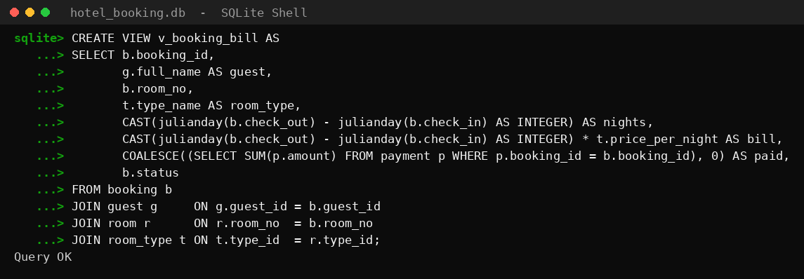
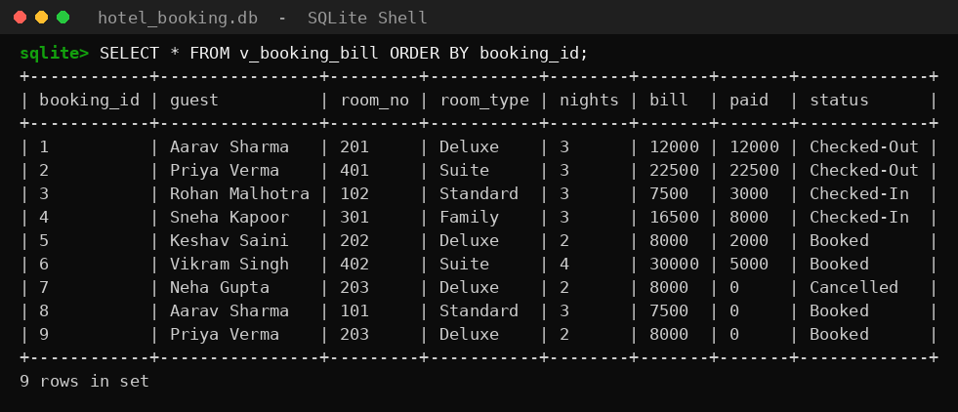
Output 6 – View v_booking_bill
4.7 Pending Payments
Bookings whose bill is more than the amount paid are listed with their balance. Cancelled bookings are ignored.
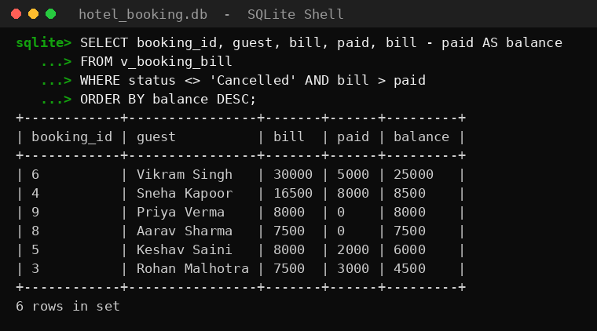
Output 7 – Pending payments
4.8 Revenue by Room Type (GROUP BY)
Non-cancelled bookings are grouped by room type with the number of bookings and the total billed amount.
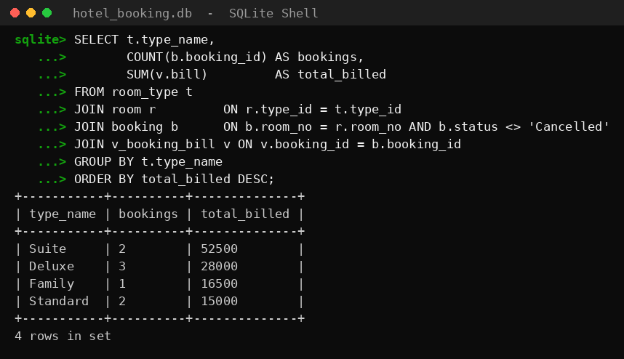
Output 8 – Revenue report
4.9 Check-out, Cancellation and Room Status (UPDATE)
Booking 3 is checked out, booking 6 is cancelled, and rooms of guests who are checked in are marked Occupied.
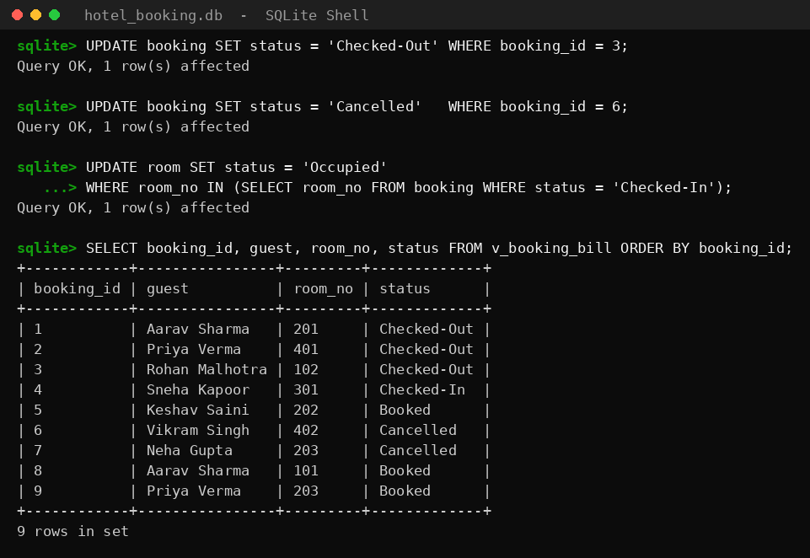
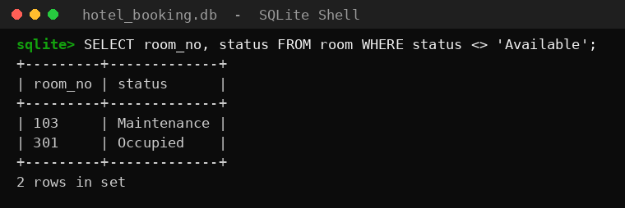
Output 9 – UPDATE statements
4.10 Integrity Constraints in Action
Five wrong inserts are tried: check-out before check-in, a duplicate phone number, an unknown guest, an invalid room status and an invalid payment method. The database rejects all of them.
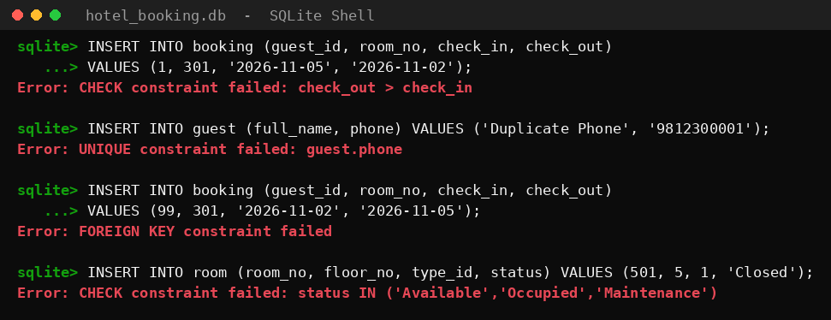
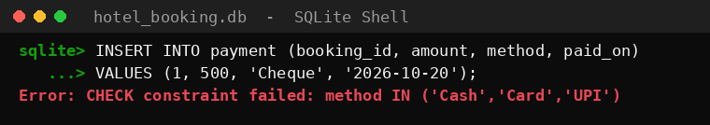
Output 11 – Constraint violations
4.11 Transactions – ROLLBACK
A booking and its payment are inserted inside a transaction. Inside it the counts rise to 10 and 7; after ROLLBACK they are back to 9 and 6, so nothing was saved.
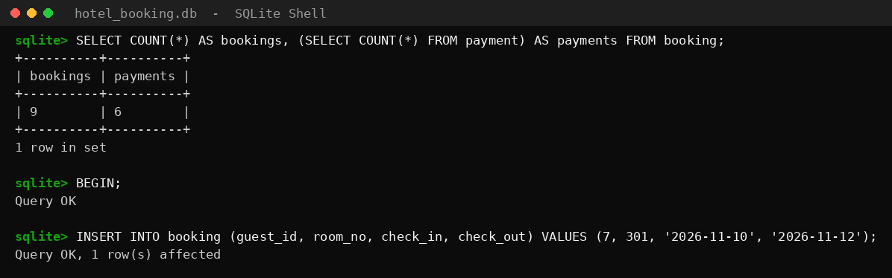
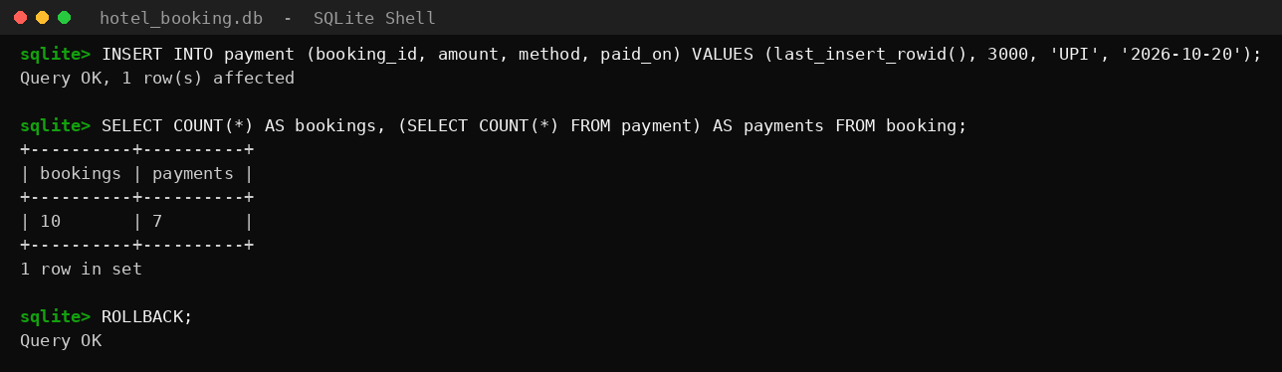
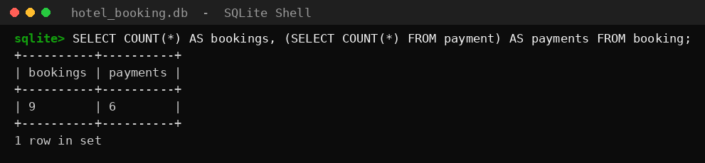
Output 12 – ROLLBACK
4.12 Transactions – COMMIT
The same two inserts are repeated and this time confirmed with COMMIT. Booking 10 now exists with its payment: 2 nights × 5500 = 11000, of which 3000 is paid.
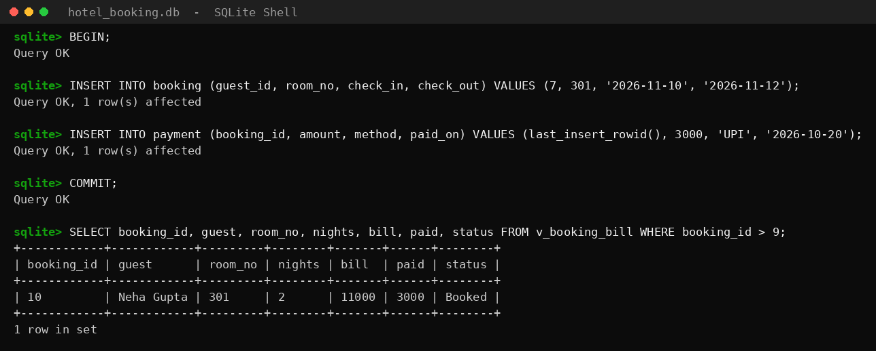
Output 13 – COMMIT
4.13 Index and Query Plan
EXPLAIN QUERY PLAN shows how the database runs a query. Before the index it SCANs the whole booking table; after CREATE INDEX it SEARCHes the index.
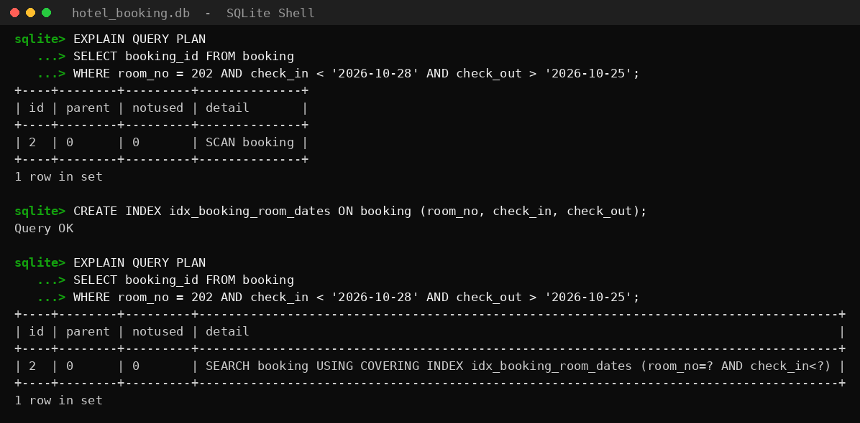
Output 14 – Query plan before and after the index
4.14 Rooms Never Booked (LEFT JOIN)
A LEFT JOIN with IS NULL finds the rooms that have no booking at all.
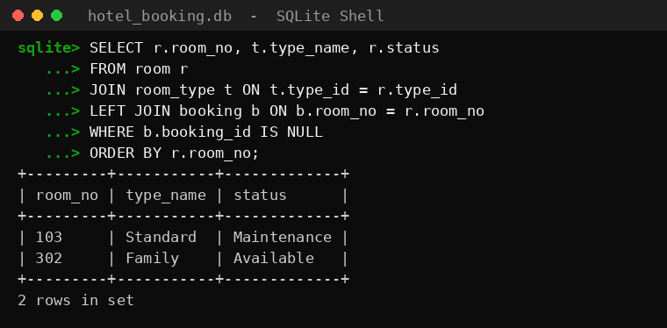
Output 15 – LEFT JOIN
4.15 Payment Statistics (Aggregate Functions)
Payments grouped by method, and the average, shortest and longest stay of the bookings that were not cancelled.
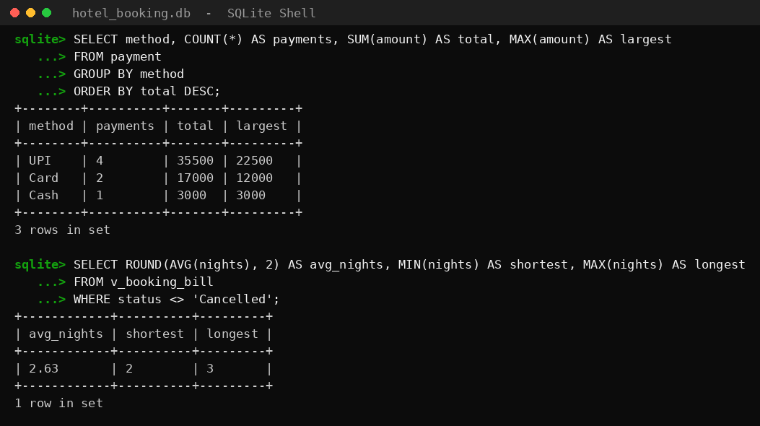
Output 16 – Aggregate functions
CHAPTER 5. TESTING AND VALIDATION
The following test cases were checked against the output shown in Chapter 4. In every case the result of the database was the expected one.
No. | Test | Expected result | Result
1 | Insert booking with check-out before check-in | CHECK constraint error | Passed
2 | Insert guest with an existing phone number | UNIQUE constraint error | Passed
3 | Insert booking for guest 99 (does not exist) | FOREIGN KEY error | Passed
4 | Insert room with status ‘Closed’ | CHECK constraint error | Passed
5 | Insert payment with method ‘Cheque’ | CHECK constraint error | Passed
6 | Book room 202 for 25–27 Oct (already booked 24–26 Oct) | Rejected by trigger | Passed
7 | Book free room 203 for 25–27 Oct | Accepted as booking 9 | Passed
8 | Available rooms 25–28 Oct | 102, 201, 203, 301, 302, 401 | Passed
9 | Bill of booking 4 (3 nights × 5500) | 16500 | Passed (16500)
10 | Balance of booking 6 (30000 − 5000) | 25000 | Passed (25000)
11 | Transaction followed by ROLLBACK | Counts return to 9 and 6 | Passed
12 | Transaction followed by COMMIT | Booking 10 with payment saved | Passed
13 | Query plan after CREATE INDEX | SEARCH using the index | Passed
CHAPTER 6. CONCLUSION AND FUTURE WORK
6.1 Conclusion
The Hotel Room Booking System shows how a well-designed relational database protects the data of a hotel. Normalisation removed repeated data, constraints rejected every kind of wrong input, the trigger made double booking impossible, the view calculated bills without storing them, transactions kept a booking and its payment together, and the index made the availability search faster.
6.2 Limitations
- Only the database layer is built; there is no user interface or login.
- Taxes, discounts, meal plans and room-service charges are not included in the bill.
6.3 Future Work
- A web or desktop front-end for the reception, and online booking for guests.
- Staff and housekeeping tables, GST and discounts, seasonal prices and printable invoices.
- Moving to a client-server database such as MySQL or PostgreSQL for many users.
REFERENCES
- R. Elmasri and S. Navathe, Fundamentals of Database Systems, Pearson.
- A. Silberschatz, H. Korth and S. Sudarshan, Database System Concepts, McGraw-Hill.
- SQLite Documentation – https://www.sqlite.org/docs.html

